Drop-Out Fuse (DOF) / Isolator Switch

1. Introduction:-
Drop-Out Fuses (DOFs), also known as Drop-Out Fuse Isolators, are protective devices used in medium-voltage overhead power distribution systems. They serve a dual purpose: protecting equipment from overcurrent and providing a visible disconnection point for maintenance.

2. Construction and Components:-
Component | Description
Fuse Carrier | Holds the fuse link; drops out when the fuse blows, providing visual cue.
Fuse Link | A replaceable element that melts under fault current to interrupt the circuit.
Insulators | Typically made of porcelain or polymer; support and isolate live parts.
Hinge & Latch Assembly | Allows the fuse carrier to pivot and drop when the fuse blows.
Contacts | Ensure electrical continuity when the fuse is intact.
3)Working Principle:-
- Under normal conditions, current flows through the fuse link.
- When a fault occurs (e.g., short circuit or overload), the fuse link melts.
- The fuse carrier drops down due to gravity and hinge design.
- This breaks the circuit and provides a visible disconnection, ensuring safety for maintenance.

- Technical Specifications (Typical for 11 kV DOF):-

Parameter | Value
Rated Voltage | 11 kV
Rated Current | 100 A to 200 A
Breaking Capacity | Up to 10 kA
Insulation Type | Porcelain / Polymeric
Mounting | Pole-mounted
Operating Temperature | -10°C to +55°C
Standard Compliance | IS 9385 / IEC 60282-2

5. Applications:-
- Protection of distribution transformers
- Isolation of faulty sections in overhead lines
- Tap-off points in rural electrification
- Substation feeder protection

6. Advantages:-
✅ Cost-effective protection
✅ Simple visual indication of fuse operation
✅ Easy to replace fuse links
✅ Minimal maintenance required
✅ Improved safety during maintenance due to visible isolation

7.Diagram:-
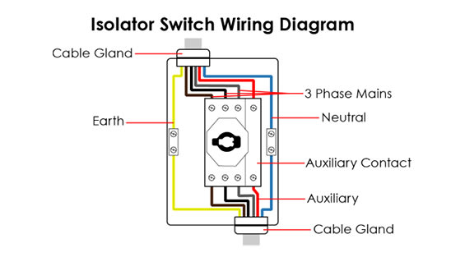
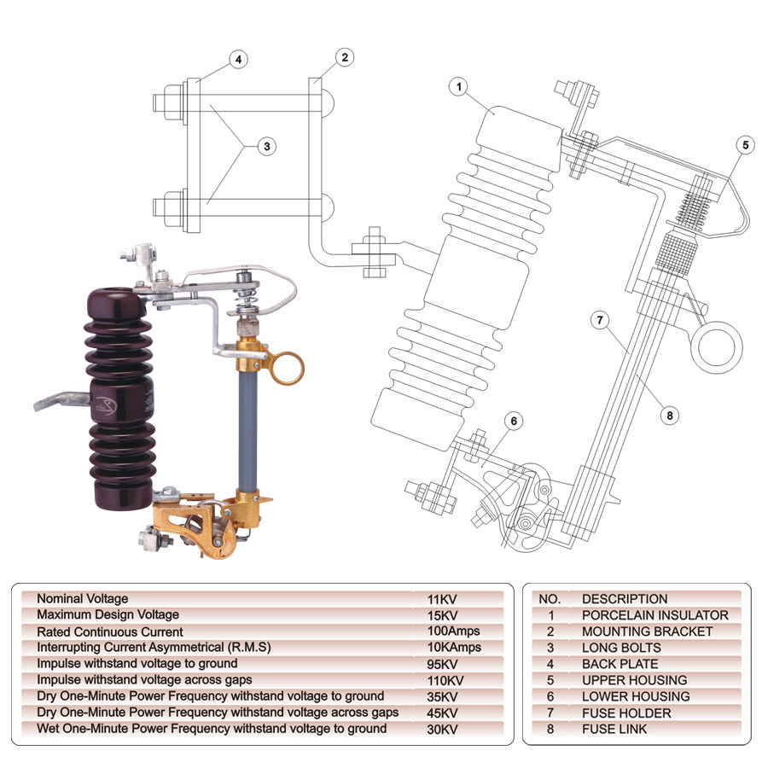

8. Safety Considerations:-
- Always isolate upstream supply before replacing fuse links.
- Use insulated tools and PPE.
- Ensure proper earthing of the system.
- Regular inspection for corrosion or mechanical wear.

9. Comparison: DOF vs Isolator Switch:-

Feature | Drop-Out Fuse (DOF) | Isolator Switch
Protection | Yes (fuse link melts) | No (manual operation only)
Visual Disconnection | Yes (fuse carrier drops) | Yes (manual open/close)
Automation | Manual | Manual or motorized
Cost | Lower | Higher
Maintenance | Low | Moderate
Application | Overhead lines, transformers | Substations, switching yards

10. Conclusion:-
Drop-Out Fuses are essential for reliable and safe operation of medium-voltage distribution networks. Their simplicity, cost-effectiveness, and dual functionality make them a preferred choice in rural and semi-urban power systems.

Presented By:-1)Harshad Gholap
2)Atul Yuvare
Guide By:-Prof.Bhushan Kadam

